THE ADVENT CHRONICLE
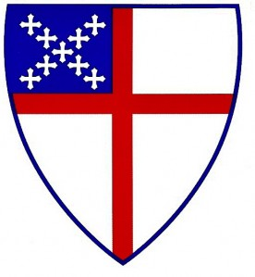

Our Purpose: Love God, Love One Another, Make Disciples
11251 SW Hwy 484
Dunnellon, FL 34432
(352) 465-7272

Office Hours
Mon., Wed., Thurs., 8:30am – 12:30pm
Tuesday 8:30am – 4:00pm
May 2024
episcopalchurchadvent@aol.com

CONTENTS

Message from Fr Barrett ∙ ∙ ∙ ∙ ∙ 1
Food Pantry Schedule ∙ ∙ ∙ ∙ ∙ ∙ ∙ 3
Holiday Food Basket ∙ ∙ ∙ ∙ ∙ ∙ ∙ ∙ 3
Holy Faith Corner∙ ∙ ∙ ∙ ∙ ∙ ∙ ∙ ∙ ∙ ∙4
Episcopal Church Women∙ ∙ ∙ ∙ ∙ 5
Milestones ∙ ∙ ∙ ∙ ∙ ∙ ∙ ∙ ∙ ∙ ∙ ∙ ∙ ∙ ∙ 5
Up Coming Events∙ ∙ ∙ ∙ ∙ ∙ ∙ ∙ ∙ ∙ 6

Weekly Events
Sunday 9am Services
First Sunday of the month is a Healing Segment

Tuesday: 2ndTues. Vestry Meet at 5:30pm

Wednesday: First Wednesday of the Month is Food Pantry 9am - Noon
3rd ECW Meet at 10:00am

Thursday: 9:30am EOF

Friday: 12pm Stations of the Cross Only in Lent

Saturday:
1st Saturday of the Month DOK Meet at 10:30am

8:00amBob Evans Fellowship on the 2nd Saturday of the month – All are welcome

Clean-up 8:00am on the 3rd Saturday of the month

A message from Fr. Barrett

The Lord be with you!

This year Pentecost is celebrated on May 1th. This is when a lay lector gets to read all those tongue twister names listed in Acts 2:7-11!

Pentecost comes from the Greek pente, meaning 50. It comes fifty days after Easter. It is also known as Whitsun or “white Sunday.” It is a customary day for baptism in which early catechumens wore white robes. It also has roots in the Anglo Saxon word wit which has come into English in its original form. We define it as humor, but its original meaning was understanding. Hence its association with the understanding of diverse languages described by Luke in the Book of the Acts of the Apostles which comes immediately after the four gospels in the New Testament.

Pentecost is the fulfillment of two Bible promises. Joel 2:28: “I will pour out my Spirit on all flesh” and Jn. 16:13: “When the Spirit of truth comes, he will guide you into all the truth.” There are three events associated with Pentecost-a great wind, fire, and speaking in tongues.

Wind brings to mind Ezek. 37 where the prophet is commanded to speak to a valley of dry bones. The breath of the Lord animates them and they take on flesh and live. At Pentecost Peter preached and 3000 were baptized that day. It is considered the birthday of the church. Fire reminds us of Jesus words in Mt. 5:14; “You re the light of the world.” After Pentecost the gospel began to spread from Jerusalem.

What about speaking in tongues? Some commentators think Pentecost is the reversal of the Tower of Babel judgment where God confused the universal language of the people. This may be so, but I offer another explanation. Christian Pentecost (fifty days after Easter) shares that date with the Jewish festival of Shavuot which comes 50 days after Passover. It is one of three festivals during which all Jewish males were to present themselves at the temple. That is the reason for all the tongue twister names in the reading on Pentecost Sunday. The diverse crowd of Jews also included proselytes who were Gentiles in the process of conversion to Judaism. But why did Peter witness on this day? Jesus had risen from the dead 50 days ago and been with them 40 days before his ascension? Why were the disciples given the gift to speak in the tongues of other nations that particular day? Was it because it was Shavuot? Wasn’t that the perfect day to witness to a mass audience of Jews from all over the Roman Empire that Jesus of Nazareth had risen from the dead and that he was the Messiah of Israel and the Son of God?

We should remember the reason the disciples were given the gift of tongues on Pentecost. It was to facilitate the proclamation of the gospel to all people and all lands. Speaking in tongues is not a parlor trick to show off our spiritual gifts. The apostle Paul dealt with this very misunderstanding among the believers in Corinth. He advised them: “Tongues, then, are a sign not for believers but for unbelievers, while prophecy is not for unbelievers but for believers. if, therefore, the whole church comes together and all speak in tongues, and outsiders or unbelievers enter, will they not say that you are out of your minds?” (1st Cor. 14:22-23) and “If anyone speaks in a tongue, let there be only two or at most three, and each in turn; and let one interpret. But if there is no one to interpret, let them be silent in church and speak to themselves and to God.” (1st Cor. 14:28-29). Speaking in tongues then is to facilitate witnessing and hearing the gospel. It is not for showing off or a sign of spiritual merit.

Pentecost closes the Easter season. It is followed by Christ the King Sunday which introduces the ordinal Sundays (the Sundays after Pentecost).
Father Barrett

Peace Father Barrett

Food Pantry Schedule
May 1, 2024

Pickers: Charlie Pratt/Pat Birmes

Floater: Stella Bender

Holiday Food Baskets

Congratulations!!!

We have come within $18.00 of having the Easter Food Drive completed. What a challenge this was for everyone. Times are tough, but with preference and dedication we have proven that we can accomplish miracles. Thank you for all that you have done and continue to do to promote this ministry.

As you have heard we have opened a Go Fund Me account on Facebook. The object of this fund raiser is to assist with funding future Holiday Food Drives. Your contributions will still be needed and appreciated. you will find the information to check out our page at the bottom of this report.

We ask and encourage you to copy, paste and forward to all your face book contacts. The more exposure that we have the greater our chances of raising these funds.

We are seeking your input in the fund-raising ideas, that we may consider using. A meeting is scheduled for Saturday morning May 11th at 10:00 AM, here at the church. We encourage you to be present or get your ideas to Al Sickle, prior to the meeting.

https://gofund.me/d5117539

Submitted by

Al Sickle

Holy Faith Prayer List Apr 28, 2024
(Reminder to update your prayer requests bi-monthly.)
*Pray for those with urgent needs:
Keith Woodin; Fay B.; Bob & Carole Byron; Gina Sluder

Pray for those with long term needs:
Ella Geiss; Maggie Phillips; Virginia Brandon; Ralph Warner; Janice Williams; Renee Cannon; Cuong Ly; Corky Alicea; Kyle Weems; Eugene Thomas.


**************************************************************************

What’s Happening at Holy Faith?
Brick Building Dec 3

- Every M, W, F 10a-1p – DCS, Inc. Senior Hot Lunch♥
- Sun, May 5 - Cinco de Mayo Fiesta FUND RAISER. NO COFFEE HR.
- Sat, May 11 – DCS,Inc. sponsors FreeD.O.M. Dental Clinic
- Mon, May 6 & 20 - Food Pantry
- Sat, May 18 – 1:00pm Thank You BBQ for Fr. Ladd & Fr. Bill

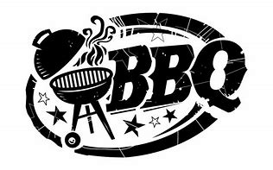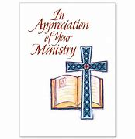
BIBLE STUDY with Ray
Offering a new Bible Exploration each week…Tuesdays at
9:00 am in Faith Hall

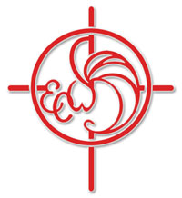

Episcopal Church Women

The ECW thanks all who supported the recent Spaghetti Dinner. Who knows? Like the Shrove Tuesday Pancake Supper, it may become an annual event. Thank you, everyone!

Upcoming items of interest.

The Basket Raffle is our next fundraiser. Please create a basket to donate for this event. The baskets will be on display during the month of May and raffle tickets can also be purchased during that time. Tickets are $1 each and six for $5. The raffle will be held after church service on June 2. We always have lots of participation from both basket makers and ticket buyers, so let’s continue that tradition!

Upcoming dates to put on your calendar:

May 5 Ingathering of CPC donations
May 15 11:30 Lunch out at Stone Creek
June 19 9 AM breakfast out at Bob Evans-no regular meeting
July 17 9 AM breakfast out at IHOP-no regular meeting
Aug 21 10 AM First meeting of new calendar year-2024-2025 planning

Milestones
If your birthday or anniversary is not listed or is incorrect please contact the office and let us know– we want to include you with our blessings and best wishes on your special day.
BIRTHDAYS

Judy Viles 05/04
Jack Schnabel 05/09
Jeanne Dooley 05/15
Rachael Spanjer 05/17
Shirley Thomas 05/19
Gordon Herrick 05/21
Ronald Purnell 05/22

Anniversaries

Monforte, Bruce & Missy 05/02
Carlton & Avis Nettles 05/23

________________________________________________________________________

If anyone is interested in the Psalm 121 Ministry (Pray Warrior’s) please speak to or call the Office for now (352) 465-7272

The Church is in need of Acolytes, Altar Guild helpers and Ushers. If anyone would like to volunteer or be a substitute please give Liz Herrick a call for Acolyte at (352) 291-4878 or e-mail her at tinlizziehr@yahoo.com, For Altar Guild, please call Kathy Consiglio at (352) 465-7272 or e-mail her at ktgjjd6@gmail.com, Bonnie & Dick Purnell for Ushers. Call Bonnie (386) 559-2491 or E-mail: Purnell.bonnie@gmail.com or Dick at (727) 992-2397 or E-mail: Purnell.rt@gmail.com

Upcoming Events

May 1, 2024 – Food Pantry 9am to Noon

May 1, 8, 15, 22 & 29, 2024 3:45pm – Choir Practice

May 2, 9, 16, 23 2024 – (EOF) Exploring Our Faith at 9:30pm

May 4, 2024 – Daughters of the King Meet at 10:30am

May 11, 2024 –Bob Evans Breakfast Fellowship at 8:00am – All are Welcome

May 14, 2024 – Vestry at 5:30pm

May 15, 2024 – Episcopal Church Women (ECW) - Luncheon at Stone Creek at 11:30am

May 18, 2024 - Clean-up Day at the Advent at 9:00am

Corrections

If you see that an error was made, please call the office at (352) 465-7272 so that I have the right info.
Thank you, Lesley Ciullo
_____________________________________________________________________

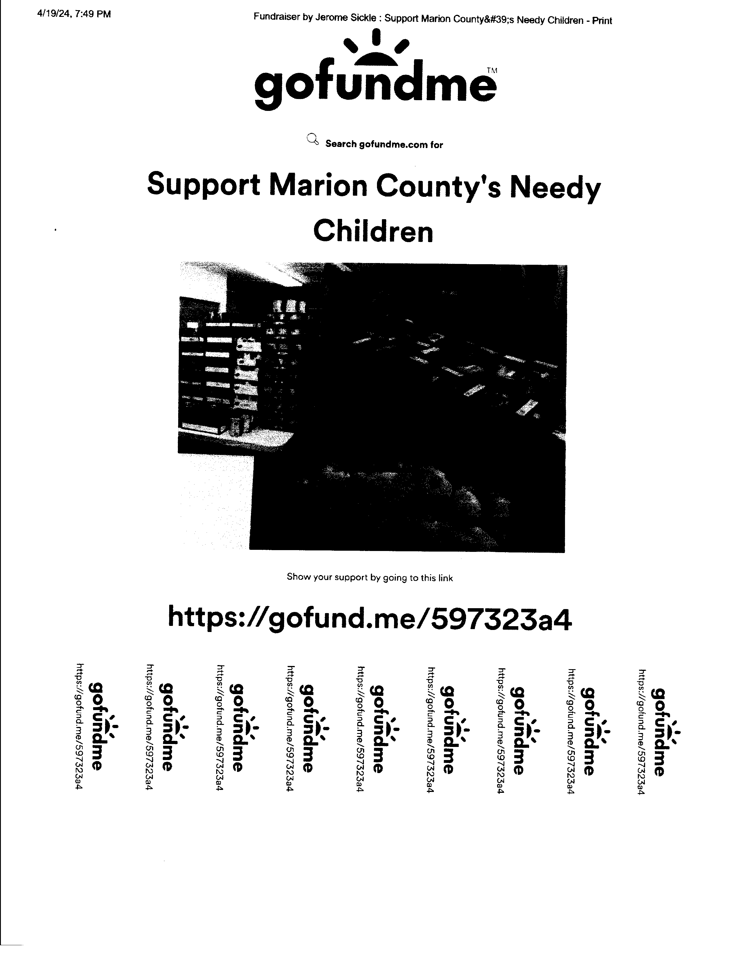
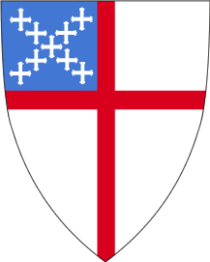
The Advent Chronicle
Episcopal Church of the Advent
11251 SW Highway 484
Dunnellon FL 34432-6413

